Sun (Sydney, NSW : 1910 - 1954), Friday 12 October 1928, page 7
ENVOY SUED
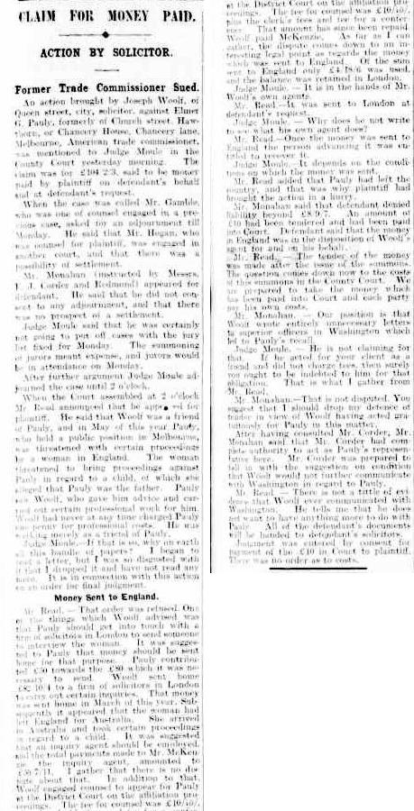
SOLICITOR'S ACTION - STRANGE CHARGES ‘ACTED IN BLACKMAIL CASE' MELBOURNE’
Sensation followed sensation In a case in the County Court to-day in which Joseph Woolf, one of the best known solicitors in Melbourne, sued Elmer G. Pauly, formerly American Trade Commissioner for Australia, for £104 2s 3d, being money paid out on Pauly's behalf, and at his request. Mr. Woolf set out in his affidavits filed in court that his claim arose, out of negotiations, which he conducted on Pauly's behalf about. March 23 last when Pauly came to him and alleged that he had been threatened with blackmail by a Miss Manktelow, of London and Melbourne. Two letters were handed to him by Pauly, said Woolf, one purporting to have come from the mother of the girl, dated February 1928, and addressed from Clapham Common S.W. This letter commenced : "I wonder what manner of man you are, and do you realise what a nervous wreck you have made of my daughter Mary? She is suffering the tortures of hell, and waiting patiently to have news of you. You seduced her under a promise- of marrying her as soon as you got your divorce." This letter went on to demand that the daughter must return to Australia and that Pauly must provide for her, and contained a threat to Inform the American Embassy at London if this were not done. The second letter purported to have been written by Miss Manktelow to Pauly, and contained an announcement that her baby was expected in May, and requested that arrangements should be made for a bed in a nursing home. It concluded : "You know I love you whatever happens — yours, Mary."
SENT £50 TO LONDON
Woolf "said that it was then arranged that he should send £50 to England for the purpose of settling the woman's claim, and that Pauly handed him a cheque, for that amount. Later he advised Pauly that the amount was not sufficient, and that he would arrange for a further £32 to be added to the £50. Pauly at, that time, he said, denied having had illicit relations with the woman. Miss Manktelow, however, arrived in Victoria about May 7. Subsequent correspondence which took place between Miss Manktelow's solicitors and Mr. Woolf was traced by Woolf. He said that he had definite proof that the woman had arrived in Melbourne with the definite purpose of obtaining, £1000 from Pauly, as the latter would not face publicity, owing to his official position. Woolf went on to relate that he had engaged a private detective to make certain reports on the character of Miss Manktelow, who, he alleged, was at times known as Marie Alwyne, and Mary Alwyn, and her association with another woman known as, Lillian Bird. The object of these investigations, he said, were to prove that Miss Manktelow was not a desirable character, and that as such she was liable to deportation.
"RELATIONS ADMITTED"
Later in the proceedings, Mr. Woolf went on, Pauly did admit relationship with the woman, and subsequently, on July 25, 1928, an order was made at the Melbourne Court of Petty Sessions against Pauly for £10 pre-maternity expenses, and also an order for 15s a week, in respect of the illegitimate child of Mary Manktelow. Later, Woolf alleged, Pauly refused to pay the amount claimed by him as out-of-pocket expenses. Woolf alleged that he did not charge any fees. Upon Pauly's refusal to pay. Woolf alleges that he wrote him a long letter, tracing the history of the negotiations. This letter told an extraordinary story of the interviews. It set out that although Pauly had denied relationship at first, "you subsequently informed me that she had been your mistress continuously, and that you had paid the rent for various places, including a flat she had established, and that you had introduced her to your friends and your wife, and your associations with her were more or less a public fact. Other passages from this letter were:— “You admitted to me that you went with her to Adelaide, and spent several days with her there, and that she had letters from you in which you admit your relationship with her and appear to have been delighted with the glorious time you had with her. She publicly boasted that these letters were sufficient to force you to pay £1000." I saw General Blamey (Chief Commissioner of Victoria Police) and he said he knew Mary Manktelow and had met you and her and your wife at a social function and that he knew or suspected relations between you and this girl, and he was not surprised at her blackmailing you. I discovered also that you public association with this girl had been a matter of general knowledge, and a number of people pitied your wife." “I told you l would try and get her deported before the birth of her child if possible, as this was the only way to prevent the conspiracy against you succeeding.” I have advanced over £100 for you out of my own pocket. I have not charged you professionally, and have met with startling rudeness. You are like a woman with a cancer. When a cancer can only be removed by surgical operation, she objects to any surgery and only wants rosewater to disguise the smell. A surgeon does not supply rosewater even to stupid or craven people."
The sum of £10 was Paid into court by Pauly. Judge Noale entered judgment for £10, by consent, on condition that the letters in the possession of Woolf be handed to Pauly's solicitors.

Herald (Melbourne, Vic. : 1861 - 1954), Friday 12 October 1928, page 3
MR. ELMER PAULY TO PAY SOLICITOR £10
Result of Suit Against U.S. Commissioner
REMARKABLE LETTERS ABOUT A WOMAN
Judgment by consent for £10 was entered by Judge Moule for Joseph Woolf, solicitor, of Queen street, Melbourne, in his claim for £104/2/3 from Elmer Pauly, formerly American Trade Commissioner in Melbourne, which was heard in the County Court today. Mr R. Monohan, who appeared for Pauly, asked that his Honor should make an order to prevent Woolf communicating with Washington any further regarding his client. Mr A. L. Read said there was no evidence to show that such letters had been written, and his Honor pointed out that he had no authority to make an order. Attached to the claim were a number of letters. One read: — 10 Lavender Gardens, Clapham Common, London, London. 14/2/28. Dear Elmer:- I am still waiting to hear from you to know the reason why you have stopped corresponding with me. You have received my cable asking to arrange my passage for me to return to you. My baby is expected in May, so will you please make arrangement for a bed in a nursing home for me. . . You have by now received my mother's letter. She wishes you to marry me. Then I hope you will have some arrangements made definitely for our marriage as soon as your divorce is through… I cannot understand at all why you have never written to me. Surely you are not going to break all your promises. I was under the impression that all southern gentlemen were men od their word, and I hope that I am not mistaken…. I hope and pray that I am wrong in thinking you are anything but my same Elmer. I am not feeling well and I am very unhappy not having news. You know I love you whatever happens – Yours, Mary.
"BLACKMAIL CONSPIRACY"
Another letter, written by plaintiff to defendant, read:— I regret that you should have written me such a letter. You will please recall the following facts:— You called on me on Mar ’27 last. You told me that you were entirely innocent with regard to Miss Manktelow. This, of course, was absolutely false, as you later stated ….. You said that any claim by her would ruin you if there was any publicity…. I sent £32 to London. I informed you of this, and you stated that you were unable to find £32 (a balance owing), but you thanked me very warmly for my help.
At the time of sending the balance I see that if she were to arrive in Australia I hoped to be able to have her arrested and deported as a blackmailer. You asked if that could be done, and I said, “ Yes, the immigration Act permitted certain classes of people being deported.” I also said that I hoped by my XXXXXX to protect you by having her deported.
On May 7 you informed me that she had arrived in Australia. I called on her. You accompanied me and you waited for me until my return, as you were very much alarmed. I then informed you that I would see the Police forthwith. You asked whether my visit to the Police would involve publicity. I said that the Police did not publish their communications but that it would be impossible to keep the matter wholly quite. I insisted on your making a complete statement of your association with Miss Manktelow.
You Informed me that you had paid rent for her at various places . . , and that you had introduced her to your friends and your wife; that your association with her was more or less public fact. Last Thursday you admitted to me that you went with her to Adelaide, and spent several days there with her. She publicly boasted that your letters were sufficient to force you to pay £1,000, or any sum she demanded, otherwise she would break you and your career ....
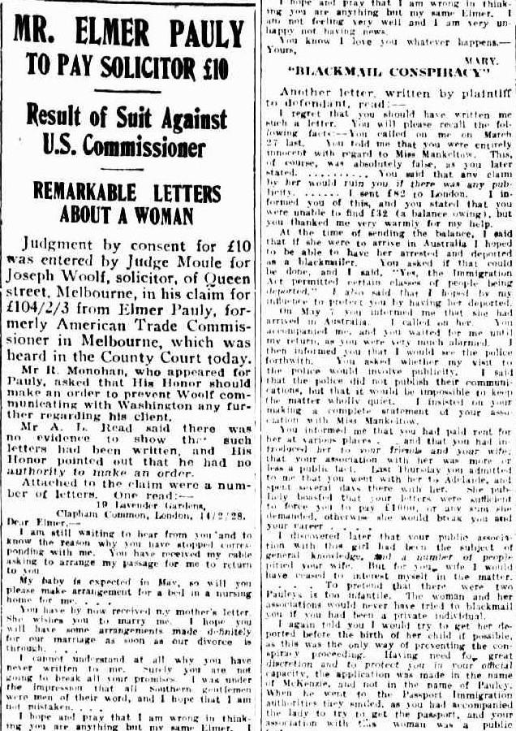
I discovered later that your public association with this girl had been the subject of general knowledge, and a number of people pitied your wife. But for your, wife I would have ceased to interest myself - in the matter. . . . To pretend that there were two Pauly’ is too Infantile. The woman and her associations would never have tried to blackmail you if you had been a private individual. I again told you I would try to get her deported before the birth of her child if possible, as this was the only way of preventing the conspiracy proceeding. Having need for great discretion and to protect you in your official capacity, the application was made in the name of McKenzie, and not in the name of Pauly. When he went to the Passport Immigration authorities they smiled, as you had accompanied the lady to try to get the passport, and your association with the woman was a public fact. . . . I have moved heaven and earth to save you from ruin. I consider my actual professional loss for not attending to other retainers is at least 300 guineas. 1 have advanced you £100 from my own pocket, because you were not able to find the money yourself. . . . Now that 1 have achieved this result and saved you, you show your gratitude by being rude and boorish…..were in the grip of an octopus of conspiracy, and I saved you by herculean effort. You have, in return, shown a boyish incapacity to appreciate your position as a man, failed to do your duty us a husband and a father, and as a friend, who is expected to play the game as a gentleman under all conditions.
JUDGE SAYS HE IS DISGUSTED.
In opening the case for Woolf, Mr Head said that this year Pauly was threatened by a woman named Mary Mankeltow, alias Mary Alwyne with affiliation proceedings. Pauly consulted Woolf regarding this mutter, and was given advice. Plaintiff had never at any time charged Pauly for professional services, but had merely acted out of friendship for Mrs Pauly. His Honor (holding up a bundle of letters attached to the claim): If that is so, why all this? I read the portion of some of these letters. I was so disgusted that I dropped it and have read nothing else.
Mr Monohan said that Pauly denied the indebtedness alleged. In addition to giving advice, Mr Woolf's activities included writing letters to superior officers in Washington, which led to Pauly's withdrawal from Australia. '

