Part 4 - “The Ardath Murders - The Wash Up”

The Coroner’s enquiry commenced at 10am on Tuesday 20th January 1931 at the Bruce Rock
Courthouse and was conducted by Acting Coroner, Mr P. A. Pinel J. P.

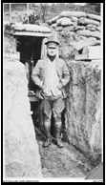
Appearing for the Police were: Detective Sergeants Doyle and Muller.
Hubert Stanley Wyborn Parker, left (a qualified solicitor and distinguished
military officer who had served at Gallipoli and in France during WW1.) appeared for McCaskill, Gordon James for the National Mutual Life Assurance Company and Langley Lloyd for his deceased sister Mrs Eva Trena McCaskill and nephew Robin.
(As previously mentioned, Hubert S. W. Parker would, later on, appear for the Mine owners of Youanmi Mines in the Coroner’s Inquest into the death of
William Halbert’s brother, James Lindsay Halbert.
(Review page 60 for more on Mr. Parker.)

The Bruce Rock Post and The Corrigin and Narembeen Guardian of the 23rd January 1931 reported on the inquest. The first witness called was an elderly gent Mr. Alfred George Prior.

“Alfred Geo. Prior, driver of a meat cart in the employ of Geo. Slade, at Ardath, stated that on Tuesday, December 30th, witness was delivering meat at Ardath and Yarding. He also delivered mail, newspapers and bread. About noon that day he was near the cross roads at Wm. Merredith's place. He saw McCaskill working in a paddock a little distance from the road. He was sewing bags. Witness had a newspaper for McCaskill, also some bread. McCaskill waved to him to go on.
Witness went on to Yarding and delivered goods to other customers. The last place he called at prior to returning to Ardath was Brekell's. He then returned to McCaskill's and tied his horse to the gate, arriving there about 4 pm. He took the paper, mail and bread in to the kitchen. He saw a man lying in the pathway, his feet were pointing west. Witness didn't know the man. He took the bread inside and returning saw he was dead. There was an axe on the table in the kitchen. He did not notice anything on it. The man was blue in the face and was not breathing. He was dressed in blue dungaree pants and was very cleanly shaved. As far as he knew there was nothing round the man's neck. He did not see any rope hanging from a beam. A motor car was standing outside the fence facing west. Witness got back into his cart and drove away with a view to seeing (if) McCaskill was about. He went to Ardath where he saw Merredith and Bell at the post office. He spoke to the girl in the office and she told him “Mr. Merredith had notified the police”.

“Dr. Malcolm Sylvester Bell said that on Tuesday, December 30, at 4.45 p.m. he received a
telephone message from P.C. Williams. Witness, with the constable and Mr. Severtus Bruce, went to McCaskill's farm. They arrived there at about 5 p.m. He saw Mr. Merredith another man named Bell and boy named Cook. Merredith informed him there were three bodies in McCaskill’s house. He viewed the body of a dead woman, also the dead child lying at the feet of the woman. There was a pool of blood on the right-hand side of the bed. As they came out of the house, he saw P.C. Williams with an axe similar to that produced with crust of blood. He next saw the body of Wm. Halbert in an outer room of the house covered with a tarpaulin. The body was lying under the roof of the verandah. The skin was livid and there was a distinctly darker blue above where a rope was tied round the neck. The rope was drawn tightly around his neck. The body was dressed in boots, dungarees, shirt and a dirty white handkerchief round the neck. There was a longer piece of rope hanging from the beam above. Witness made a brief examination of the three bodies. The post mortem revealed that Mrs Trena McCaskill’s death was due to shock from a wound on her face which might have been caused by an axe or similar weapon, the wound in the back being received after death. The reason for thinking this is that the back wound has more of a post mortem
appearance, being less stained with blood at the margins and contained fluid blood, while the
facial wound contained clotted blood. The baby Robin Victor McCaskill's death was due to shock from wounds which might have been made with both front and back of an axe or similar
instrument striking the head and body.

In Wm. Halbert's case the post mortem revealed that death was due to heart failure from asphyxia due to strangulation by a rope or other narrow cord which encircled the neck above the tracheal cartilage.
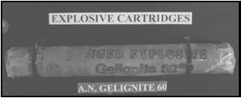
Victor James McCaskill's death was found to be due to head and upper thorax being blown off by high explosive, probably inserted in the mouth by the right hand, which was not found at the time. A right rib was retrieved a hundred yards away. (Ed. Note: The right hand was found some years later by the subsequent owners of the property.)

“John Scott Rae, farmer, residing at Ardath, stated that he had known McCaskill for about two years and his wife about seven years. He had a farm adjoining McCaskill's. On December 30th, about 2.30 p.m., he was harvesting in a paddock adjoining McCaskill's property. He saw McCaskill going through his paddock towards the house. Witness waited until he came along. Witness
noticed he was carrying something in his arms covered with a towel. When McCaskill approached, he lifted the towel and showed witness the body of the baby and collapsed. All he said was “My poor child”. He said that man of mine has murdered my wife, killed my child and then hanged himself. He asked witness for assistance, which he promised to render on taking his team home. There was a cut on the baby's head, cheek and arm. When witness reached home, he met Merredith, who was on his way to Ardath with a team and a load of wheat. Witness asked him to phone to the police from Ardath. Witness returned to McCaskill's, where he was still, walking about carrying the baby in his arms. He went into the house and saw the body of Halbert lying in the doorway. He found Mrs McCaskill lying on the bed covered over with a sheet. There was a piece of rope round Halbert's neck. Halbert was dead and witness covered his body. Witness asked McCaskill how it happened and he said he had given the boy notice and he was to have gone that afternoon. The boy said on receiving notice "You'll be sorry for this." He said that the boy went down the paddock to sew some bags and he (McCaskill) went down shortly after in a different part. Later he missed Halbert and thinking he might be at the stables, went there, but Halbert was not there. He found the body of Halbert hanging from a beam on the door and his wife and child dead in the bedroom. Witness asked him why he thought the lad did it, and McCaskill said the boy had a nasty habit of blowing his nose in the kitchen. He told him about it and said that it would cost him his job if he did it again. The boy did it again and he told him he would have to go. He said he would go that afternoon. He asked him why he would have attacked his wife and child and he replied that the only reason he could think was that his wife complained of the habit. Witness eventually persuaded McCaskill to put the baby down and go across to Brekell's. Witness asked what he considered, had been used to cause the deaths and he pointed to an axe which was on the kitchen table and similar to that produced.

Mr. Parker: You have known McCaskill for a long time. Didn't he seem peculiar? — “Yes”. Didn't he seem very fond of his wife and child? — “I could hardly say so, he did not appear very much so.”

To Mr. James: I would not say he was exactly insane.

Wm. W. Merredith, farmer, residing at Ardath, adjoining McCaskill's on the north side, said that on the 29th December during the afternoon witness met McCaskill at Ardath. McCaskill told him he was in trouble with his harvester and asked for advice as to whether he would have it repaired or get someone to take the crop off for him.
He asked witness if he would take the crop off and he told him he couldn't, as his hand was
leaving. McCaskill told him he had given Halbert notice and he replied “You'll be sorry for this” McCaskill said to the boy "Why will I be sorry. You can burn my crop it’s of no value to me or you might shoot at me, but you might miss, and in any case whatever you do, you’ll get a stretch for it.” Witness then told McCaskill he could borrow his harvester when he had finished.

The next day about 2.30 p.m. he saw McCaskill coming in a car. He turned the corner and went up towards Yarding. The car stopped at a heap of bags in the paddock. After loading wheat witness went to Ardath. About an hour later witness returned for another load. On the way to Ardath with the second load of wheat he saw Rae at the stables and he informed witness of the tragedy at McCaskill's place. A Mr Bell and witness drove into Ardath and rang up the doctor.

“On arrival, he saw the body of Halbert lying on the ground outside covered up with a tarpaulin. They all went in through the kitchen. He saw the dead body of Mrs McCaskill and the body of the baby on the bed. P.C. Williams and the doctor later arrived, and in company with P.C. Williams witness conveyed the bodies to Bruce Rock. The following day between 10.30 and 11 a.m. witness saw McCaskill standing near the place where Halbert's body had been. He appeared to be looking for something. Witness asked him the time of the funeral McCaskill staggered out and said "I want my mother; I want my mother." Witness said that his mother would probably be in Bruce Rock by then and he suggested that McCaskill should go into Bruce Rock and see her. He asked witness to get him a case of papers, but immediately changed his mind, saying leave them.
McCaskill then motored to Bruce Rock.

At 3 p.m. he saw McCaskill’s car coming along the road from the direction of Bruce Rock. It passed along the road in front of witness's house towards McCaskill's. It was bumping along the road. It turned into McCaskill's farm and went straight towards the haystack, where it pulled up. About three minutes later he heard a loud explosion. He turned and saw smoke in the air at McCaskill's place. Witness went in the car to McCaskill's haystack and found the body of McCaskill minus head, shoulders and arm lying on the ground close by the haystack. Witness threw a bag over the body, and almost immediately P.C. Williams and J. Courtney came along and they placed the remains, in the car and conveyed same to Bruce Rock.

Mr. James: Did you see a box on the verandah? — Yes. It was too large to kick away or to be used for hanging. Was Halbert's body directly under the rope? — Practically. Did you see any signs of a meal on the table? — Yes. Do you consider they had dined? — No, they had not. Did you see much of McCaskill? — No. He seldom called on me. The photos produced are of the haystack.

Thomas Edwin Brekell, farmer, six miles north-west of Ardath, knew the McCaskill family for some time. Their property adjoins his. About 5 p.m. on December 30 a car drew up to his blacksmith's shop, and Rae came across to him. He saw Rae, who told him of the tragedy. He was speaking to McCaskill and on witness asking him who committed the crime McCaskill said the lad had done it and had hanged himself. Witness asked how he knew the lad had hanged himself and he said "I cut him down." Witness told him he had no right to do so, as that was the police's job. McCaskill said he cut him down because he was gasping and he revived him. He also said he could have killed him with the same axe as he used for killing his wife and child. On further questioning, McCaskill said that he had given Halbert notice and he said "You will be sorry."
Witness told him he could not take notice of such a remark, as it was mere bravado and that there must be some stronger motive. He took witness round to the car and showed him the impression of the baby's foot marks on the bonnet. He said, "Look at me; a big fellow like me could not defend my wife and child." Witness asked him if they had had a row. He was a good lad as far as he knew and did his work well. McCaskill said he was good with horses, but slovenly with farm work.
Witness contended he was a good worker and carried on well after his own workers had knocked off. At McCaskill's request witness called Wray, who was at his (witnesses) house having a cup of tea. McCaskill accepted an invitation to stay the night. About 9.30 Mr. Farrall, jun., called and took McCaskill into town, returning after 11.30 p.m. At breakfast time witness again referred to any motive for the crime and McCaskill said the lad had been inquiring about workers' compensation and that it was very funny thing that about, two weeks ago the cow had butted him in the back. McCaskill said he asked to see the injury, but Halbert had said it was alright. McCaskill and his wife had been talking about this. He said his wife was heavily insured and he also had told the boy that. He also said that the boy had taken his wife's insurance papers, as he could not find them. Witness said the boy didn't show much brains if he took the insurance papers and hanged himself. He said that there was a tin on the table full of dirt and that there was gelignite and a detonator in the tin and the lad had planned it for three weeks. He said when he went to his place, he would see what was in the tin. McCaskill went straight across to the table and picked up a tin similar to one produced and took a plug of gelignite out of it, to which was attached a small piece of fuse and a detonator. Witness asked what the lad intended to do with it and he replied ''Blow up the place, I suppose”. Witness put the gelignite back in the tin and hid it under a big tank. They went back to the house. McCaskill showed him a paper signed by the boy stating that during the time he was in his employ he had met with no accidents.

Mr. Parker: “Do you agree with other witnesses that this unfortunate man was insane? — He seemed very eccentric.”

To Mr. James: “He seems more eccentric than insane.”

Mr. S. Bruce, Clerk of Courts, Bruce Rock, stated that about 5 p.m. on December 30th he
accompanied P.C. Williams and Dr. Bell to McCaskill's home near Ardath. He saw the three bodies. On Friday, January 2nd, at 9 a.m., he accompanied Detective Sergeant Muller and P.C. Williams to the place and assisted the police in making a search of the house. He examined pass books — Union Bank (Perth) pass book was up to date. The last entry was a deposit of £70, £250 by State Savings Bank paid in to his credit on December 16th. Another book E. T. McCaskill, (Savings Bank) showed a withdrawal of £250 on December 15th. Commonwealth Bank book on Narrogin branch (Eva Trena McCaskill) was closed on October 25th, with the withdrawal of £86 10s 4d.

To Mr. Parker: He kept a peculiar, sort of diary. Witness saw his correspondence over 10 years and it seemed to indicate he had a decided “kink”. He was very strange and did not seem to be normal. I have seen no insurance policies.

P.C. Williams stated that on December 30 at 4.15 p.m. he received a message from William W. Merredith and in company with Dr. Bell and Mr. Bruce he proceeded to McCaskill's farm. On arrival there, he met Merredith who told him that there were been committed (stet), and that there were three dead bodies in McCaskill's house. Between the corner of the structure and two galvanised iron tanks he saw the dead body of William Halbert lying on the ground.
Immediately above the head was a single piece of rope. In the passage way was a large box standing on its end. The box was about 3ft. x 20 inches. The wall was about 8ft from the ground. He went into the kitchen and bedroom and saw the body of Mrs McCaskill lying on the double bed, also the body of the child lying near her feet on the opposite side of the bed. He found the axe (produced) on the table in the kitchen. It had blood stains on the face and handle. He proceeded with Dr. Bell and Mr. Bruce to Brekell's farm. Midway between the two farms he met Wray and McCaskill. Witness asked McCaskill what had happened and he replied that his wife and child had been killed and he wanted his mother. He gave witness his mother’s address as, 35 Bagot Rd. Subiaco. He was wearing grey dungaree trousers, shirt and military boots. He had bloodstains on his clothes and on hands and hairs of his arm. He was too hysterical at that time to supply any particulars.
Witness, with the assistance of Dr. Bell and Mr. Bruce had the bodies placed on Mr. Merredith's truck and conveyed to the hospital morgue. About 11 o'clock that night McCaskill arrived at the Bruce Rock police station with Mr. Farrall to inquire if his mother had arrived. Witness informed him that she had not, and advised him to go home, promising to take his mother out when she
arrived.

On December 31st between 10.30 and 11 a.m. witness saw McCaskill in Bruce Rock and told him his mother and sister had arrived, and were having a sleep at the hotel. He asked McCaskill to come into the Courtroom and give him a statement as to what took place. He said "What do you want to know”. Witness replied that he wanted the facts concerning the tragedy. McCaskill said that he wanted to see his mother first and that he would explain it all to him later.

About 15 minutes later witness saw McCaskill with his mother and sister in a room at the hotel. He asked for a statement, to which McCaskill said, "About 1 p.m. on the previous day he took his wife and baby for a swim" He said "No, my wife did, I stayed in the car with the baby," He said that he then took them home. He took his wife and baby out of the car near the house and then went to have a look at the soak at the north end of his property near the junction of his property with Merredith's, to see if it contained any water, but found it empty. He then went to the next
paddock to sew bags. Questioned, he said he got suspicious of the lad he had working for him in that he had become peculiar in his habits. Asked if he had paid him his wages, he said "No, I have paid him nothing since April 7th." Asked if he intended paying him, he said he was going to make arrangements with the I.A.B. He said the reason (for) his suspicion was that he had recently had his wife insured for £2000 in the National Mutual Insurance Co. He then went into pretence of fainting. Coming to, he said he suspected the lad of having stolen the insurance papers.
Witness shook him and asked if the papers were gone. He still went on feigning fainting. He said the insurance papers were in his wife’s case in the bedroom and that he would explain the whole matter later.

Witness beckoned his mother and told her not to let him out of her sight, and she agreed.

Witness called up to the courtroom to obtain further information re insurance. About the same time, he received a telephone message from Inspector Clarke regarding the insurance, and that there was a detective coming from Perth to investigate the case.

Witness then returned to the police station at about 1.30pm when Mr Baxter Jnr. came to say, "Do you know McCaskill has gone out of town?”. Witness went to the hotel saw the mother and asked her where McCaskill was. She said he had just left the room to go to the lavatory. Witness found he had gone home towards Ardath. Witness secured a car and pursued him. At one stage he saw McCaskill's car on the road but lost it in the bend of the road. When he eventually approached the property, he saw a cloud of dust from a haystack, which he took to be a willy willy. On reaching the gate he saw McCaskill’s car, and pulling up, was told by Merredith that he was about 5 minutes too late. For McCaskill had blown himself up!

He took witness round the haystack, where there were signs of a great explosion and McCaskill's body badly damaged, fragments of body and dust scattered for about 100yds. Witness also found his driver’s license and portion of a £10 note etc. Witness had the remains gathered and removed to Bruce Rock. At the morgue witness searched the pockets and hip pocket of the trousers and found £2 7s 4d in notes, silver and copper.

On January 2nd witness with Detective Sergeant Muller and Mr. P. A. Pinel visited McCaskill's and Brekell's properties. At McCaskill's farm he found a tin containing gelignite between two tanks at the rear of the house. The centre ping had a detonator and a piece of fuse about 3 inches long attached to it. There was a piece of rope hanging from the wall plate in one knot. Deceased Halbert was about 5ft 6in or 5ft 7in. From where the box was it would have been impossible for Halbert to have put the rope round the wall plate and impossible for him to have hanged himself and left the box where he found it. With Detective Muller he attached piece of rope around wall plate and applied approximately same weight as McCaskill's and on cutting it the strands were frayed, whereas the rope supposed by McCaskill to have done the hanging was not frayed.

Detective Sergeant Muller stated that he had investigated the tragedy and also insurance policies on the life of Mr and Mrs McCaskill, with the National Mutual Insurance Co. There was an
insurance policy for £2000 (October 24th, 1930) for seven years; also, a policy on the life of McCaskill (14th October), for £200 for seven years. McCaskill was asked to take out the insurance policy for a longer period but refused. Halbert was 18 years of age on 7th September, 1930. He was a most inoffensive boy. He had not seen his mother for three years, but always corresponded with her. He was looking forward to visiting home after harvest as he was expecting a good cheque, not having drawn any money since being at McCaskill's. It would have been impossible for Halbert to
have hanged himself from the position of the beam and the rope.

To Mr. Parker: You saw a lot of writings in McCaskill's hand which covered a number of years. Did they suggest anything? — “Yes, that he was mad, or had a decided kink?”
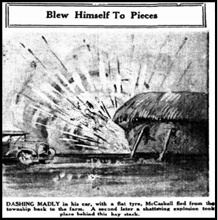
After adjourning the Court for half an hour, the Coroner returned the following verdict:
William F. Halbert came to his death by being
strangled by a rope by Victor James McCaskill; that Mrs Trena McCaskill's death and also that of the baby, resulted from shock due to wounds inflicted by Victor James McCaskill; and that McCaskill died from a gelignite explosion self-caused; the crimes having been committed whilst he was of unsound mind.

The Death Certificates of the four victims state:

(Death Certificate of William F. F. Halbert)
Cause of Death: … being strangled with a rope by Victor James McCaskill.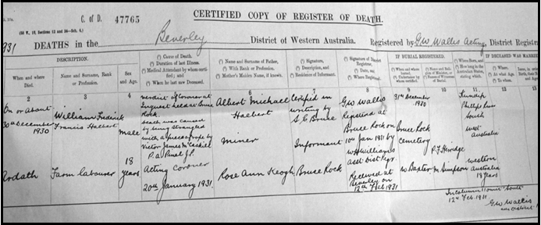

(Death Certificate of Eva McCaskill)
Cause of Death: Shock caused by axe wounds inflicted by Victor James McCaskill.
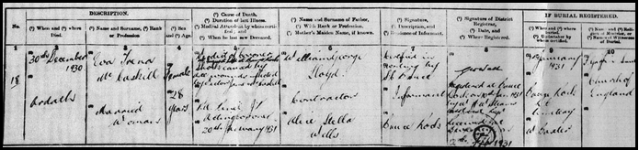 (Death Certificate of Robin McCaskill)
Cause of Death: Shock caused by axe wounds inflicted by Victor James McCaskill.
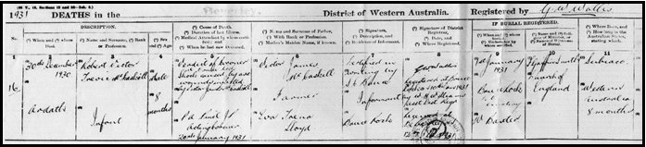
(Death Certificate of Victor McCaskill)
Cause of Death: … by an explosion, such explosion being the result of his own hand.
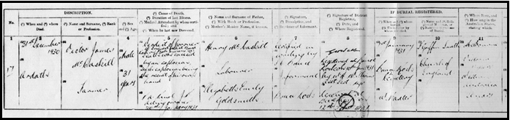
(Left below, gravesite of William F. F. Halbert, Bruce Rock) (Right below, McCaskill gravesite, Victor, Eva Trena & Robin at Bruce Rock.) Can you believe it! Eva goes to the grave with her son, and what remains of Victor, their brutal killer, …. shares the grave!
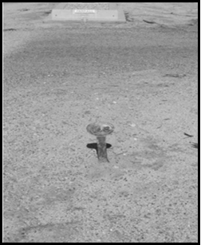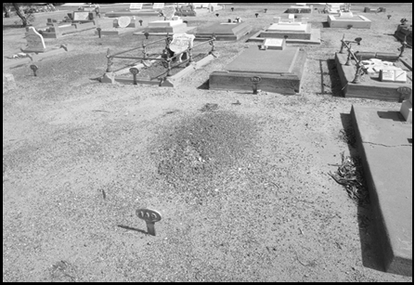

From the Mirror Newspaper of Saturday 3rd January 1931:
‘A TRIPLE FUNERAL’ Only 17 people stood round the grave when two coffins, one containing the bodies of Mrs. McCaskill and another the husband, were lowered into the grave on Thursday, the funeral was originally arranged for Wednesday afternoon and many friends came in to Bruce Rock specially. But when the interment was deferred on Instructions from the C.I.B many of them
returned to their homes.

‘LETTER FOUND. BABY - A GREAT JOY’ The baby, a bonny boy of eight months, seems to have been the late Mrs. McCaskill's greatest joy in life. She adored him, her friends say, and in a letter, she wrote to a girlfriend but never posted, she said that ‘though Vic's castles had fallen to the ground, they hoped for better times’, and ‘above all, I have my baby’. ‘He is eight months old and has five teeth, he can walk a little holding onto the rail of his playground. He is a great joy to me.'

‘HOME OF TRAGEDY’ The McCaskill home at Ardath was practically devoid of comfort.
Apparently with the idea of getting on his feet before he spent money on an elaborate house, McCaskill and his wife lived in a rough shed, with no floor, only a crude partition separating the living room from the bedroom. The furniture was inexpensive and comfortless, the only attractive piece being: a silver-plated dressing case that had been presented to Mrs. McCaskill on her 21st birthday. In the ''dining" room there was a makeshift table, with cases for cup boards. The presence of a baby was evidenced in the toys about the house. On Christmas Day, Mrs. McCaskill, while
having dinner with a friend, told her that they hoped to have a new home where they would be able to ask their friends before next Christmas.

‘ILLFATED FAMILY’ The tragedy of Mrs. Eva McCaskill’s death is the latest and most terrible phase of a long run of ill luck that has dogged her family for years. Her father was a member of an
aristocratic Welsh family, but coming to Australia he had to go a good few rungs down the social ladder to take up camel driving. It was at Leonora where his wife still resides that Eva Lloyd was born. Tragedy hit the family hard when one of the boys went to Adelaide and was killed in an
accident. Badly shocked by his boy's death, the father died or disappeared a short while later. But exactly what happened to him no one seems to know. Another son was killed in the war, while a surviving boy is in the Wagin district, and there is a sister in Bellevue. (Ed. Note: There was no sister).

“From the Editor” - William died intestate (without a will) so his mother Rose Ann Halbert sought authority from the Supreme Court to administer her son’s estate. William Halbert’s only asset was a “50-pound interest in the estate of V. J. McCaskill deceased”. Rose Halbert was granted probate and received the fifty pounds in wages owed to Billy.

Detective Sergeant Charles Muller, born in Ballarat, Victoria, joined the W. A. Police Service in 1898. He was attached to the Perth C. I. B. in 1901 and after 35 years of service, retired to North Beach. He served in Coolgardie and Kalgoorlie over time, and as a J. P. after retirement. He left a widow and two sons.

Did Eva have terrifying thoughts racing around in her head when Victor turned up for lunch
without Billy, on the fateful day? What excuses did Victor offer as to Billy’s non-appearance? Billy shared every meal, it was his “only remuneration” for now. Did she know Billy was already dead, had she seen his body? Did Victor’s demeanour seem even stranger than the haunted man he had
recently become. Did she have any inkling as to what may lay ahead for her and Robin? He’d
already taken her money just weeks ago and placed a large insurance on her demise, 2 months ago. That poor, unhappy women, what fears flashed though her mind over the next 2-4 hours?
(You may have noticed, that in this document, I have changed McCaskell to McCaskill about 100 times! All of the newspapers of the day used ‘kell not ‘kill. Victor and BDMWA used ‘kill. (Editor.)
The Ardath property was sold not long after these events to a family that have worked and
expanded the farm, successfully, over 3 generations. The right “hand” belonging to Victor was found in the haystack many years later.
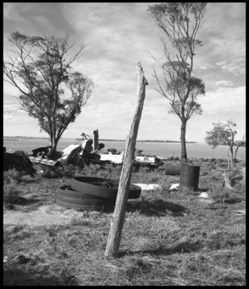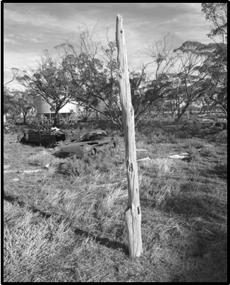
(Above, all that is left of the “house of horrors” is this gimlet verandah strut.)
Tenders Returnable at Bruce Rock, 2/5/31. 23/1586. Avon Location 14545, being the whole of the land comprised in conditional purchase leases 28791/55, 12033/56 standing in the name of VICTOR JAMES MCCASKILL, containing 1000 acres situated 4 miles west of Ardath, described as 572 acres 1st class mallee and gimlet. I80 acres 2nd class white-gum, balance 3rd class scrub, 970 acres cleared. 1000 cy. dam, 280 chains 5, 6 and 7 wire, 73 chains 2, 3 and 4 wire, and 30 chains posts fencing, 2 camps stable and chaff house. Stock and plant that may be in our possession and belonging to place at time of purchase. 112 acres fallow. (Courtesy Sunday Times, Sunday 19 April 1931, page 21)
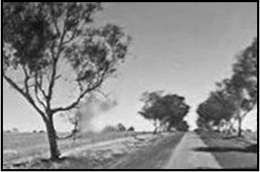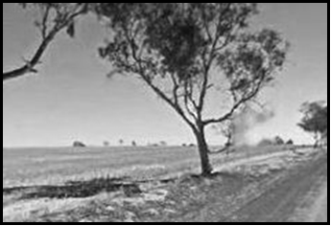
Google cars, wandering around the country took these photos, but whenever I show them, people suggest that they can see a woman holding a child, both with hat or bonnet, a man to the right and maybe a fourth person above! I absolutely agree! But as I see it, this man Victor, must have a beard, and I cannot confirm he did. Though he did have a long chin? Grab yourself a magnifier.
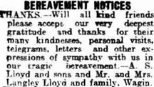
The Lloyd Family coped…. just.
(Left, family thank you. Courtesy Kalgoorlie Miner 12 January 1931)
A year later, in 1932, Eva’s brother Langley and sister-in-law May Lloyd placed memoriam notices for all deceased in the Papers, yes including Victor!
McCaskill. —In loving memory of our dear sister and nephew,
Trena and Robin, who were called home on December 31, 1930.
“Sunshine pauses, shadows fall, love and memory outlast all” Inserted by May and Langley.
McCaskill. — In memory of Victor, who departed this life on January 1st 1931. R. I. P. Inserted by May and Langley.
Seven years later, in 1937, Eva’s mother places another memoriam notice.
McCaskill. —In sacred and everlasting memory of my beloved only daughter Trena (Babe), and grandson, Robin. Killed December 31 1930. A. S. Lloyd, Leonora.
Seventeen years later, Eva’s mother Alice Stella, and her brothers posted yet another memoriam to their daughter and sister (Kalgoorlie Miner Wed. 31st Dec. 1947)
Lloyd-McCaskill. —In sacred and everlasting memory of my only daughter, Eva Trena and grandson Robin who passed away December 31, 1930. Inserted by mother and brothers.

War had come and gone but the emptiness lived on. I’m sure there would have been many other “end of year memorials” to the dear departed, these above are just a few.

“A mum never forgets, and her brothers will never forgive.”

“Strangely there was a copycat offence within days of these cruel murders!!”
(Truth, Perth, Sunday 18 January 1931, page 1)
BLEW SELF AND BOY TO PIECES, ITALIAN'S MAD RAGE, FARM HORROR!
A ghastly tragedy involving the diabolical slaughter of a little boy aged 2 and ½ years and at the same time the terrible death of his Uncle, an Italian, marked the sequel of a family quarrel at Greenbushes. Following a violent quarrel with his sister-in-law on a farm about four miles from the township, Giacomo Pietroboni, 27 and single, carried the woman's little son into a paddock where, a few minutes later, they were both found frightfully shattered, having been blown up by a stick of
gelignite. Hardly had the horror of the similar happening at Bruce Rock, when Victor McCaskill, blew himself to pieces been overcome, when, news of this tragedy reached the city. The one
shocking method of taking life, was probably the inspiration of the other.
Blackened Her Eyes: According to a report from Greenbushes, Pietroboni, who was single, and lived and worked on the farm of his married brother, engaged in an argument with his sister-in-law on Tuesday afternoon. The argument passed from heated words to blows and in a struggle that
ensued the woman, it is said, had both her eyes blackened. Called to the scene by his wife's cries Pietroboni's brother interfered and stopped the brawl. He was not however satisfied with
Pietroboni's demeanour after the affair, and apparently fearing more trouble with his thoroughly aroused brother, asked a neighbour to send for the police. A few minutes after the message, had been sent Pietroboni was seen to leave the house and walk into a paddock adjourning the
homestead. It was thought by the rest of the household he was merely going out to bring in the cows. This was one of his usual afternoon jobs.
Took the Child: Nor was curiosity or suspicion aroused when he picked up his brother's 2 and ½ year-old son and carried him into the paddock with him. It was a perfectly normal procedure and one that invariably followed when he went to bring in the cows. He was very attached to the child and whenever it was possible, he took him with him. When he had been gone about five minutes those in the house heard a terrific explosion coming from the paddock in the direction the man with the child had taken. About the same time Constable Bingham of Greenbushes arrived and rushing down the paddock found the mangled remains of Pietroboni and the infant. They had been blown to pieces by a stick of gelignite. An inquest which is expected to throw more light on the ghastly happening will be held in Greenbushes on Tuesday.
(Greenbushes is about 380 kilometres south-west of Bruce Rock.)

Explosion on Farm GREENBUSHES. Jan. 20. — An inquest concerning the deaths of Giacomo
Pietroboni (27) and Ferruceio Pietroboni (2) was held at the Greenbushes Courthouse today before the Acting Coroner (Mr. D. H. Gibbney). Domenica Pietroboni said that Giacomo Pietroboni, who was her brother in-law, and her husband had tea about 5 p.m. on January 13, and afterwards they went to dig potatoes. On the previous evening witness had complained about her brother-in-law having hit the cows with a stick, and he used such bad language that she was sorry that she had spoken. Shortly after he left the house on January 15, she found a note written by him, which stated: 'Inside 24 hours you and I will be dead, or I will kill one of the boys.'

Shortly after reading this, she went to where the men were digging potatoes, carrying a child in her arms. When she asked the meaning of the note, her brother-in-law rushed at her with a digging fork, saying: 'I will push it through your belly.' The fence was between them and, dropping the child, she rushed towards the house.

Giacomo followed her, and immediately he did so, her husband picked up the child and followed them. At the gate leading to the house. Giacomo caught up with her, made a swing with the fork and missed. He swung out with his fists, striking her on an eye and the stomach. She was felled and her husband prevented her from being kicked. Immediately afterwards she left to telephone to the police and some friends. Before leaving the house, she and her husband tried to persuade Giacomo from doing anything silly. The child that was blown up was not Giacomo's, but he was very fond of the boy and they slept in the same room. Domenico Pietroboni, brother of Giacomo Pietroboni, said that his brother was working a little distance away from him on the potato patch, and witness could not hear what was said, but when the trouble started, he was in time, to help his wife. After this, Giacomo apologised for having caused trouble, and agreed that one of the parties should leave the place. Witness and his brother returned to the paddock and took the two little boys’ home.

Witness said that he would go for the cows, but Giacomo would not agree to this and walked off. Ferruceio ran after his uncle, and witness appealed to his brother to leave the boy at home, to which Giacomo replied; 'Are you afraid I will carry out my threat?' and walked off, carrying the boy.
After going into the house and making a fire, witness went towards the cow yard to open the gate, and when a short distance away he heard an explosion and saw smoke. He found the bodies of his brother and his son. Gelignite was kept on the farm, but had never been used by witness, and he did not know where it was stored. His brother had always used it when clearing. Several witnesses stated that Giacomo suffered a good deal from headaches, and he had mention to one witness that when he put his head on a pillow everything went red. Sometime previously, he had been advised to consult a doctor.

Constable Bingham said that he found the body of Giacomo Pietroboni about 250 yards from the house, with the top front portion blown to pieces and scattered over an area of 20 to 30 yards. The head, arms and shoulders of the boy were 20 yards away from the scene of the explosion.
The Coroner said that he had no doubt whatever that Giacomo Pietroboni took his own life, and in doing this took the life of his little nephew.

