“The Ardath Murders -A Few Mad Days”

At the end of 1930, Victor James McCaskill was thirty-two years old, a qualified Surveyor turned Farmer, and owner of Lot 1, Ardath-Yarding Rd.
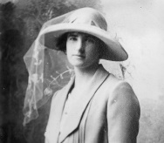
His wife of five years Eva Trena (Langley) Lloyd, aged twenty-eight, was mother to their ten-month old son Robin Victor Trevie. Baby Robin was named in honour of Eva’s youngest brother, Robin Vereker and his father Victor. Eva and brother Robin, born two years apart, enjoyed a close relationship in their teenage years as older brothers Charlie, Neville, Vereker and Langley were either away at war or elsewhere. She was a deservedly popular young married woman, well-educated and clever and also a typical “farmer’s wife”.
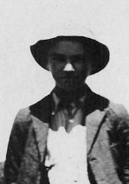
Billy Halbert, the farm hand, had turned eighteen in September and was happily looking forward to the end of harvest, his big pay packet and a trip home. He is described as “one of the mildest, most unassuming, likeable, obliging and sober young man possible to find” and indeed was “a powerfully built young farmhand and a good worker”.

Victor McCaskill was a very good-looking bloke and a tireless good worker, but lately had become moody, and both Eva and Billy had to tread carefully at times. He was apparently seen by some, as cold and calculating, jealous by nature, and suspicious of all when it came to his lovely wife. He didn’t allow her out, without being in his company.

At lunch on Monday 29th December, Victor broke into another of his unprovoked rambling tirades and told Billy that he was sacked and would have to leave the following Saturday, the 3rd January.
Billy left the table without eating, fuming on the inside but passive on the outside, he was no match for this man and his anger and he needed to be paid. He retired to his “shed” feeling sorry for Eva who now had to “calm the man down” and quieten her frantic baby son Robin, restless as a result of the discord that had just taken place.

Victor McCaskill once consolable, round about tea time, went over to his neighbour Bill Meredith’s home, looking for solace as to the poor quality of his crop and his broken-down harvester. He said in passing that Halbert (Billy) would be leaving the farm at his wife’s insistence for his “nose
blowing” around their child. “He’s been a good worker and he didn’t really deserve the “sack”, but it was done and Eva was happy to see him go, he said. McCaskill further stated that Halbert had
threatened him saying “You’ll be sorry!”, too which McCaskill had responded "Why will I be sorry, you can burn my crop, it’s of no value to me, or you might shoot at me, but you might miss, and in any case, whatever you do, you'll get a stretch for it”.

Meredith agreed the right thing had been done in the circumstances, not wanting to further upset Victor “perhaps it’s best you got rid of him then?”. McCaskill recanted saying “he finishes up
tomorrow”. Tomorrow being the Tuesday 30th December 1930, not Saturday the 3rd January 1931 as young Halbert had been told.

Bill Meredith feeling just a little sorry for McCaskill offered him the use of his own harvester once his crop was off, and he suggested as he would then have no job for his lad, perhaps McCaskill could employ him when Halbert left. Victor wandered off home a little relieved that all was not as bleak as he imagined.

Very early next morning Tuesday 30th December 1930 both Billy and his boss, Victor, went to the far (or bottom) paddock to sew bags ready for the harvest crop. They were gone a long time. Billy was being extremely careful not to “ruffle Victor’s feathers” as the banks were closed until Friday 2nd January, and he needed payment for his eleven months of hard “yakka” (aboriginal for work) to

proudly show his mother and spoil her after a hard year and much grief. Indeed, he was in need of
funds just to get home. He needed Victor to treat him fairly and not cast him off in a moment of confused anger. Oh, how he needed to be paid! “Don’t rattle the cage”, was front of mind!

About noon that day Alfred George Prior (driver of the meat cart in the employ of the local
butcher, Geo. Slade at Ardath) who usually delivered Victor’s newspaper, bread and meat was waved on by Victor who was still sewing bags in a back paddock near the cross roads and Bill
Meredith’s farm. Today was a newspaper and bread day. “Catch me on the way back” was his cry, so Alfred continued on to Yarding.

A little while later, according to Victor, Billy and he returned to the farm house for a lunch of
freshly roasted mutton shoulder and milk pudding. After enjoying this meal with Eva, Victor asked Billy to “chop the wood for the Mrs.” and that “when that was done” he was to re-join him for more bag sewing.

About 2pm Victor’s neighbour Bill Meredith (William Wickham Meredith who bravely served in WW1 with the 10th Light Horse) saw McCaskill drive his “very new” car out to a pile of bags on the far paddock.

Soon after this trip, McCaskill returned home, to see what was taking Billy so long to chop a few logs. He is shocked to find him (Billy) hanging by the neck from the killing gallows and assumes immediately it’s suicide! He knew Billy was not happy at getting the sack, but this……phew! Why do this? He cut him down, taking the weight off, then, noticing the “quiet”, hurries inside to find both
Trena and baby Robin dead in the bedroom and an axe nearby. The room was bloodied from end to end. It was a terrible blood curdling site.

Victor’s senses heightened, his legs grew weak, his eyes saw black, he could not take it in!
No man should ever have to deal with this. His young, beautiful, and very popular wife struck down
mercilessly not but a few feet away from their beautiful, innocent son.

His life flashed before him there was no future without them. What possessed young Halbert to
undertake such a frenzied attack on a family that had taken him in on trust. His instant, sharp mind summed it up…. Halbert had axed his wife and child and then, with Victor’s own words
ringing in his ears “you'll get a stretch for it”, the hapless Billy had hung himself to deny justice. Victor then turned blame back on himself, ever so momentarily, “if only he’d not sacked him, all might have been OK?” “I must get help, I don’t want to see this” and with that he bundled up baby Robin heading off, at a pace, to his nearest neighbour, John Rea.

Jack (as he was known) Rea was harvesting when he first saw McCaskill running directly and
diagonally over his paddock, the only paddock that separated their two houses. He was hailing him as he approached, running toward him with terror on his face, his whole body shaking to the point of collapse. Jack, saw he was holding and offering up a bundle (a bundle of what…he thought?). It then became apparent that whatever was in that bundle, had bled profusely and was now dead.

Victor opened the towel and to Jack’s horror he saw Victor and Eva Trena’s baby boy, its little skull was pulped in and its head almost severed from its body. McCaskill lumbered toward Jack leaning on his harvester. McCaskill said “He was booked to finish tonight” (The rumour that the hired hand at Victor’s had been sacked had not yet reached Jack and he, thinking that all was fine at the McCaskill Farm was not sure who McCaskill could be talking about.)

McCaskill went on to say however, that “Billy was sulky this morning” it seemed now that Victor

was intimating that it was Billy that was responsible for this cruel atrocity. Jack was rather taken aback, as he’d not heard an unkind word spoken about the lad since he’d arrived in the area nearly a year ago.

McCaskill then said “I’ll have to send for the police, it seems young Halbert has done this and then hanged himself, my Trena is also dead.” Jack Rea, paling at what he was hearing, said that he’d “attend to that” and that McCaskill should go to the house, and have Mrs Rea attend to him. McCaskill, while quite grateful to have Jack inform the police, insisted on going back to his dead wife with the babe saying “They should be together”.

Just before 4pm after leaving Brekell’s farm, Alfred George Prior returned to McCaskill’s farm to complete his promised delivery. After tying his horse to the gate, he made his way up the pathway to the house but on that pathway, he noticed a man lying across it with his feet pointing to the west. Alf did not know the man. He gingerly continued on, leaving the paper, mail and bread on the kitchen table, noting there was an axe on the table. On leaving he realised that the unknown man was in fact quite dead, not sleeping! The man, lying face down, was, on further inspection, blue in the face and had seemingly not drawn breathe for some time. He was dressed in blue dungaree pants and was very cleanly shaven.

Alf left immediately, it was spooky, he just wanted to be away from there. It seemed no one else was around, but nevertheless he felt cornered, vulnerable and spied upon. A chill went down his spine, his skin tightened over his face. He walked off gently to begin with then at a pace until he was half way to his horse and cart, then he bolted, too scared to look back in case there was indeed “someone” lurking at the farmhouse or even at his heels.

A motor car was standing outside the fence facing west. Alf also did not recognize the car, a new car, at that. There was no one in it. He climbed back into his cart and drove off toward Ardath
hoping to find McCaskill, or notify the police.

On arriving in Ardath he found Victor’s neighbour Bill Meredith and Dr. Malcolm Bell together outside the Post Office. He walked into the Post Office and spoke to the girl attendant saying he needed to notify a death to the Police at Bruce Rock. She told him Mr. Meredith had just done so. He assumed they were reporting the dead lad he had seen.

Meredith had in fact just contacted Mounted Police Constable Williams of the Bruce Rock Police Station, some eight miles away, regarding the McCaskill tragedy (not the lad on the pathway).
Constable Williams, upon collecting Dr. Malcolm Bell on route at Ardath, as speedily arranged,
arrived at speed (a mile a minute, they say) at Victor’s farm. (Map Courtesy of the Bruce Rock Shire)

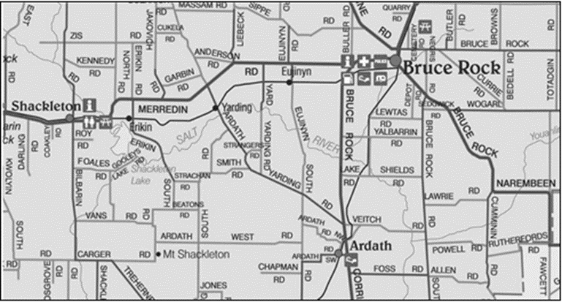

(Bruce Rock is located in the heart of the Wheatbelt, 245kms east of Perth.
It is a thriving agricultural town which had an approximate Shire population of 2,500 in the 1930’s.)

Meanwhile Rea had returned to McCaskill’s and found him ambling around and around aimlessly in his kitchen with the dead babe still in his arms.

It was about 5 o’clock when Constable Williams and Dr. Bell arrived at the property to be
mournfully greeted by McCaskill, Rea, Meredith and a young boy by the name of Cook.
Constable Williams made the following observations:
“The front gate was just four strips of wire attached to an upright, and the house was a poor two room structure of the skillion type. It had an iron roof but the walls were of wheat sacking. He also noted that there were no wall linings and the floor was just dirt, covered in the bedroom by oilcloth and in the kitchen by opened out wheat bags. The furniture was crudely fashioned from petrol tins and other cases. A new car however was parked not far away. The porch was just an extension of the roof supported by three bush saplings. The gallows, used to hang meat, was a two forked, one bar, structure.”
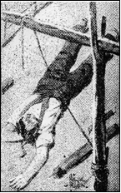
McCaskill directed them to Halbert first, face down near the gallows. A rope noose around his neck with a recently cut end. Dr. Bell suggests “Murderer? Suicide!” to which Constable Williams nodded his agreement. They covered the lad with a tarpaulin for now.
(Left, a depiction from W. Campbell Charnley’s “Famous Detective Stories” Vol. 2 No. 13, December 1947)
They moved on to the bedroom, Eva Trena lay on the floor and the babe
Robin was on the bed, still in the towel. Both mother and child had been struck with maniacal fury. Eva Trena had sustained three chops to her head area, and showed signs of other blunt traumas. The babe was similarly
mutilated, pulverised by blows from a blunt instrument. The farmhouse was a blood bespattered shamble. It was noted both bodies were still warm, but it was an intensely hot day, and just two hours or so, had passed since the
bodies were first discovered. The table was set for three and seemed partaken by three. One could only ponder how cool and cold hearted young Halbert must have been, to murder his employer’s innocent wife and babe because of his sacking, and then to top it off, denying justice to all, by hanging himself. “A coward’s way out, was the cry!”

Close beside the kitchen door Constable Williams saw an American hickory handled axe, clotted with blood. He took custody of the axe even though finger prints had moved way down his list, as for now, it all seemed too obvious “The hired hand had done it!”.

For some nagging reason however they decided to move back to where Halbert lay under the roof of the veranda and gently removed the tarpaulin for one last look. They re-examined the body, the skin was livid and there was a distinctly darker blue “above” where the rope was drawn tightly around his neck. Bell and Williams glanced at each other “Strangulation?” a question unspoken, but written on their faces, a suggestion not to be shared for now. Their combined experience demanded proof.
The victim’s eyes were dead open and his strong fingers crooked and stiffening. “Putrefaction is
advanced?” noted Dr. Bell. The body was dressed in boots, dungaree, shirt and a dirty white
handkerchief hung loosely around his neck.

There was a longer piece of rope hanging from the beam above.
Another thing caught Williams eye, the cross beam was at nine feet and the cut rope still dangled there, the fast end tied half way up one of the uprights and cut end limply laying over the cross beam, a box was nearby. “Odd” he thought as he shared this thought with Bell. Bell re-joined,
noting “there’s just one other odd point” to which Williams knowingly replied “but McCaskill has blood on him”.
Constable Williams would have to report these goings on to CIB Headquarters in Perth as soon as possible, and no doubt, a detective would be despatched (unnecessarily to his mind) as soon as his report was received, later this night.

Constable Williams asked McCaskill what time he found the bodies “Three o’clock, perhaps half past two” was his reply.

He then asked why McCaskill had so much blood on him. John Rea came to Victor’s rescue, “He’s been carrying and huddling his dead babe around since about 3pm until I returned from calling the police!”.

The grapevine was abuzz as locals ventured to the farm. All at the farm that night was
interviewed but Rae and Meredith had the most relevant accounts. Others knew bit’s ‘n pieces about the McCaskill’s, their separate lives and their lives together. Those gathered finally saw the bodies loaded on to the back of Meredith’s truck for a slow and mournful trip to the Bruce Rock morgue.

McCaskill and Constable Williams followed in Dr Bell’s car.
McCaskill’s first and desperate request on arriving back at Bruce Rock was to have his mother and sister telegraphed in Subiaco, begging them “to hasten” to him.

A likeminded and duty-bound Constable Williams was also obliged to telegraph his case to C.I.B Headquarters in Perth.

Inspector Grenville Vaughan Purdue (Perth C.I.B.) immediately despatched, that night, Detective
Sergeant Charles Muller. (More about Chief Inspector Purdue later.)

Telegraphing done, Constable Williams returned to the Bruce Rock Police Station and formally
interviewed Victor McCaskill. With a trembling voice McCaskill repeated everything as he had said it to Jack Rae.
When asked if Halbert was “hanging clear of the ground” he answered “He was, I should say a foot or even eighteen inches”. Constable Williams enlightened McCaskill on the fact the cut end of the rope “was not unravelled as one would expect?” A smirk came with McCaskill’s reply, stating, “he would have taken the weight of the body off, so as not to let Halbert fall in a heap”.

Discussion then led to what kind of knife was used and where might that knife be now, and,
moving on again, Constable Williams ventured to clarify exactly where the bodies and the axe were found. McCaskill said that he had “not touched the axe”. Constable Williams planted the seed, that finger prints could and would still need to be taken to prove “Halbert’s guilt”. That comment drew a flick of the eye from McCaskill who retorted that Halbert had been at the farm for eleven months and may have used the axe many times, including that morning when “chopping wood for the Mrs.” He went on to say, that Halbert and he had agreed that Halbert would not be paid until he was paid his “Agricultural Bank Advance on Harvest”.

(Note: At this time farming had started to take over from mining, and in 1927 land had been made
available for ‘dusted miners’, men who had lung complaints and could no longer work underground. The scheme, like so many others, was not properly administered and men who had no knowledge of farming suddenly found themselves dumped on a piece land and expected to make a go of it. At first there was some success with 1930-31 producing bumper crops but the Great Depression, triggered by the New York Stock Exchange crash of 24th October 1930 had already hit and impacted on Australia and overnight, prices had collapsed.

The wheat was “owned” by the Agricultural Bank and farmers were at their mercy and prosecuted if they tried to sell the wheat themselves. Some did and were convicted and others simply walked off the land. A very few persevered but only one or two of them went on to prosper.) (A guide to the History of Western Australia)

Const. Williams suggested McCaskill’s advance money would now be needed for his wife’s funeral? “No.....my wife was insured” (slowly divulging under further prompting) “she was insured for two thousand pounds!” (a lot for a farmer’s wife, thinks Williams) and I myself “for a thousand pounds”.

The fierce pace of the Constables questioning was clearly taking its toll on McCaskill, who feared divulging that which he did not wish to divulge or worse still, his tendency to provide spur of the moment answers which only gave rise to more questions, which he could not readily answer.
It was a roller coaster moment!

Displaying considerable distress, McCaskill begged to be excused till his mother could be with him.

Friends waiting outside the police station for him, drove him to the home of Thomas Blakell at
Ardath who had kindly invited him to stay the night. At Blakell’s, Victor mused on grievances
Halbert may have had to cause this. He suggested Halbert may have been going to blow them up as some dynamite had gone missing a couple of days ago. Blakell wondered and asked if McCaskill should have, or could have tried to revive Halbert? McCaskill said “he may have”, had he not gone inside looking for Eva who had not heeded his call.

All parties telegraphed that night, the Detectives and the McCaskill’s, duly arrived early next
morning, the 31st December 1930.
Mr. Blakell took McCaskill back to the farm early on that day so that he could change into his best clothes to attend the joint funeral and meet up with his mum and sister. Whilst at the farm, Victor showed Blakell a crude bomb saying this was probably what Halbert was going to use to “blow us up”. Blakell hid the dubious device under the tank stand.

Bill Meredith called in to feed Victor’s livestock and was surprised to find McCaskill at home,
walking around the veranda staring intently at where Halbert’s body had lain and seemingly
conducting a search under the gallows. McCaskill said he wanted to get to his mother and sister as soon as possible and Meredith obliged driving him into Bruce Rock with his son Tom and his
labourer following in McCaskill’s car.

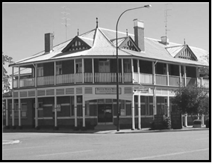
McCaskill’s mother (Elizabeth) and sister (Jean) had
arrived early and were already booked into the Bruce Rock Hotel. McCaskill asked young Tom to park his car in the lot behind the hotel and not in the street.
(Left, the Bruce Rock Hotel—Photo by Pamela Bryant 2013)

Detective Sergeant Charles Muller (a stout, kind-hearted,
middle-aged gentleman) had also arrived from Perth
(C. I. B.) early, and was going over Constable Williams’ notes with Williams at the station.

Williams stated two concerns, the straight cut of the rope and the exorbitant insurance policy on Mrs McCaskill. Detective Sergeant Muller asked Williams to re-interview McCaskill and review the timeline up to the discovery of the bodies while Detective Sergeant Muller had a rummage around the McCaskill property himself.
District Coroner Pinel, arrived at Bruce Rock about 10am and the first inquest scheduled, was that on the death of Halbert, there were three jurors in attendance. Identification was duly made, and an order for the burial was given. The inquest then adjourned sine die (no date being fixed).

William Frederick Francis Halbert was promptly buried because of the hatred whipped up by the local community, still in disbelief that something like this should happen to one of them, by an outsider. “The sooner he was in the ground, the better!”

McCaskill also requested a quick burial to clear the way for a proper grieving to take place in
respect of Eva and Robin.

The Inquest into the deaths of Eva Trena and Robin Victor Trevie McCaskill directly followed and an order for their burial was also given, with the funeral subsequently set down for 4pm that day, 31st December 1930. A large number of residents of the district were presently in town to pay their final respects to the family and to attend the funeral.

Getting on towards midday, Williams set off to re-interview McCaskill at the hotel.
He went straight up to Mrs McCaskill’s room unannounced, and found all three McCaskill’s
deeply grieved and Victor bordering on the hysterical. Williams, however moved he may have been, launched forward with his questioning as he was trained to do, firing forth his first question in a business-like manner “After you all had dinner, did you go straight back to your work in the far paddock?” “No” said McCaskill “I remember now that I took them swimming in the dam and watched on”. With the implication that this latest utterance “which came out of the blue” and was now unretractable, all blood drained from Victor’s face and he lapsed into a faint on a bed nearby.

Williams headed back toward the Police Station keen to satisfy his rumbly tummy, he hadn’t had time to eat or drink much at all during the last twenty-four hours, so furious were the going’s on in a town usually so peaceful and benign.

He met Detective Sergeant Muller on the street on his way back and told him what McCaskill had said about the “after-lunch swim” at the dam.
Muller immediately decided to ask for a post mortem to determine the times time of death of all three victims, and set off on that path to do just that. He asked Williams to cancel the four o’clock funeral and after that, to let McCaskill know of the change in arrangements.

Funeral cancelled; Williams returned to the hotel where he found Victor still slumped on the bed being comforted by the women. McCaskill was extremely alarmed to hear the news that the
funeral would not take place today because a post mortem was now deemed required.
The purpose as he told McCaskill, when asked why, was “to determine the time of your wife’s death. The swim, has altered things you see”. “Poor Trena” said McCaskill.

Williams was just about to get a start on his lunch, when at about 2pm, butcher Alf Prior came
into the station to see him, saying that between 3 and 4 pm the day before, he had called into McCaskill’s to make his deliveries, but that McCaskill was not there. “Maybe that’s when he was at Rae’s?”, he mused. “Anyway, while I was there, I was horrified to come across a lad blue in the face, lying in my pathway. “There was, at that time, no rope around the lad’s neck, nor one hanging over the killing gallows!” he said. “I immediately went on to report the lad’s death at Ardath but on reaching town found that “deaths at McCaskill’s” had already been reported on by Meredith.
I assumed for a while they were talking about the lad’s death as I had not seen any of the McCaskill’s.

It’s now 3pm and Constable Williams had just managed to get halfway through his lunch when a lad runs into the Police Station shouting “Say! Victor McCaskill’s taken his car and he’s off, hell for leather back to his farm!” (It is revealed later, according to his mother, that Victor had
calmly walked out of the hotel room after politely excusing himself “for a few moments”, on a call of nature.)

Within minutes Constable Williams set off in pursuit in a borrowed car. Along the road, he picked up a Bruce Rock citizen (J. Courtney), who had also seen McCaskill “driving with utter recklessness, like, as if he had gone mad”, realising that if he were to arrest McCaskill he would need a driver to help bring him in.

Williams was sorry and disgusted he hadn’t kept a better eye on McCaskill (as he had been asked to do). It was a fast and furious chase, but as luck would have it about four miles out of Bruce Rock (half way to the farm), one of McCaskill’s Morris Minor’s rear tyres blew out! McCaskill was not deterred however, as he bumped shatteringly along the road. Williams, equally undeterred, kept up the pace bouncing along on this deeply rutted, dusty, dirt road. Williams was catching up, half a mile, then a quarter of a mile. McCaskill drove straight through the wire “cockies” gate, heading for the haystack which was about hundred yards from the bag-built home, he skidded, and with brakes screaming came to a standstill. He jumped from his car shouting unintelligibly and disappeared behind the haystack.

The pursuit had just reached the shattered gate when a huge explosion pummelled body parts and all things in all directions from behind and over the haystack, some items more than one hundred feet in the air and, as in slow motion debris rained down over a hundred yards’ square. The explosion shook the ground and nearly knocked over Williams who had just alighted from his car. “That blast has cheated us after all” he said to Courtney.

The sound of the blast and its earth-shattering vibration was heard and felt for many miles.
Neighbour Merredith, was momentarily, a paralysed eye-witness to this astounding slow motion
volcanic performance, and uttered to friends who were with him, “He's done it!”
Meredith rushed to the scene of the explosion, and met up with Constable Williams. A frightful scene met them. All that could be done was to gather up the ghastly remnants of what a little
time before, had been a human being. It was a sickening and startling sequel to what had already been one of the bloodiest crimes in the history of the State. McCaskill had blown himself to
pieces, only his legs remained, the Gelignite, he had secreted behind the haystack previously, had blown away every other piece of him. “His arms and head were blown off and lay spread around the farmyard or impaled on stakes” he had put the double banger gelignite in his mouth and lit the fuse, it was a pre-meditated plan “B” should all else fail.

Detective Sergeant Muller was next on the scene and Constable Williams indicated as he saw it, “it was guilt not grief” that drove McCaskill to this pre-planned route of escaping justice. He (Williams) had always suspected him, ever since he saw him wince at the mention of the cut rope, and the flick of an eye when finger printing was mooted. The post mortem was just the last straw.

Williams and Muller took a closer look inside the house for clues to the couple’s lives and a
possible motive. On the 20th December 1930 McCaskill had only seventy pounds in his Bruce Rock Union Bank of Australia account, earned from previous wheat sales. On the 15th December 1930, Eva Trena had removed all her savings, some two hundred and fifty pounds, from her bank, in cash.

On the 16th December 1930 Victor put the two hundred and fifty pounds into his own account. As at her death he still had two hundred and fifty-six pounds. They also found the insurance premium receipts, from the “National Mutual Life Insurance Company” but not the policies, to which Victor had previously eluded. It seemed they now had a motive but...who was the “actual” murderer?

Meanwhile in Perth, Halbert’s distraught mother and relatives, including her nieces’ husband
Detective Sergeant Frazer, visited the Perth CIB offering up Billy’s letters as proof the boy was content, happy and looking forward to his February vacation and of course a payment of two pounds a week for all his work done since February 1930. He was obviously enjoying his first “properly paid” work and looked upon his break as a vacation, not an end to that employment.

Detective Sergeant Frazer insisted, he personally knew the boy, and he was in no way capable of
such an atrocious act. He just wouldn’t have it in him, he was a shy, but delightfully happy,
sometimes cheeky, young man with a bright future.

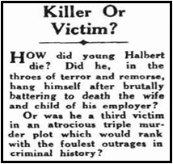
The Truth, Sydney of Sunday 4 January 1931, p. 10 reported it this way:
“The relatives of the dead youth. William Halbert, had wasted no time in bringing support to the police suspicion that Halbert might not be responsible for the killing of the woman and the child. They produced letters from him which showed that right to within a brief time before the tragedy at least, Halbert had been in excellent bodily and mental health, free from anxiety for the future, well satisfied with his financial prospects and looking forward to a holiday in Perth. There was no suggestion in the letters, other than that, he was perfectly happy and normal.”

Detective Inspector Grenville Purdue on hearing this from Detective Sergeant Frazer, immediately telephoned Dr. Malcolm Bell at Bruce Rock and ordered Halbert’s immediate exhumation. He then rang Detective Sergeant Charles Muller to have the now “additional warrant for the exhumation” sworn, promptly. (That’s now four warrants for three bodies.)

Halbert is returned to sunlight, the loosened noose (fortunately held in police evidence) was
replaced around his neck, tightened again and measurements of the rope and the body were
taken. The result...if Halbert had been suspended his feet would have more than rested on the ground. The distance spanned between the support and the (dirt) floor was eight feet, Halbert was five foot six inches tall, the rope, still hanging from the beam hung two foot six inches and six inches of the rope protruded from the noose around the boy’s neck. That totalled eight feet six inches or now as shown six inches below ground level (!), also rope or score marks were around all parts of the lad’s neck, suggesting strangulation, not hanging.

Dr. Bell also determined that Halbert’s body was already in decay but the other two were not. Halbert had died first, possibly some ten hours before the others and of course could not and did not ever partake of the mutton and pudding lunch sworn to, by McCaskill. As Bell, had previously pointed out to Williams there was not a spot of blood on Halbert, strange for an axe murderer?

Detective Sergeant Muller and Constable Williams also examined and noted that the box, in the passage way, said to have aided Halbert’s hanging, was indeed too heavy to be kicked away by a hanging, dying man, and more especially in the direction it was found. Standing on its end it was about 3 foot by 20 inches and was impossibly heavy.

All pictures below courtesy of the Saturday 3rd Jan 1931 Mirror Newspaper and Trove)
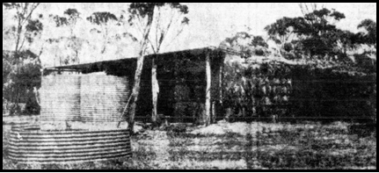
(Left, McCaskill’s unpretentious bush home at Ardath in the Bruce Rock District. It was here that the quadruple tragedy of Tuesday and Wednesday occurred.)
(Below right, Eva Trena’s body was found on the floor beside the bed at the McCaskill’s Ardath home. The dead baby was found on the
bloodstained marital bed.)
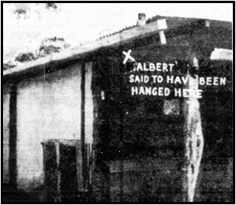
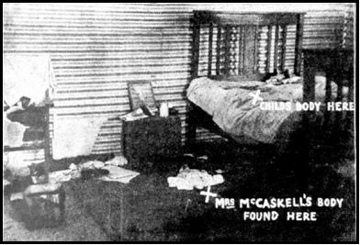
(Above left, it was from this rafter that Halbert was stated to have been found hanging by McCaskill.) (Journalist’s had altered the spelling for this paper edition, later retracted.)
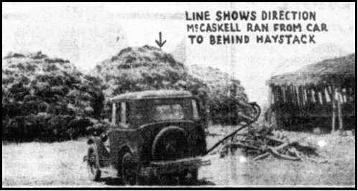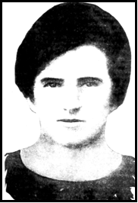
Above left, the car in which McCaskill drove wildly from Bruce Rock to his home and the haystack behind which he committed suicide.) (Above right, a depiction of Eva)
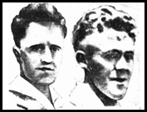
Left from the Truth Newspaper. (I’m not sure that the photo I show as Victor, is Victor! It seems some “photos” of culprits look much the same from the Truth?) Is it a drawing or a depiction rather than a photo? McCaskill left and to his right Leonard Grewcock, both vicious
murderers.

